**DBMS LAB MANUAL**

Name:Omesh Balamurugan Roll. No: 230701222

**Ex.No.:2**

**Data manipulation**

1.a. Select employee_id, first_name, last_name, salary from employees;

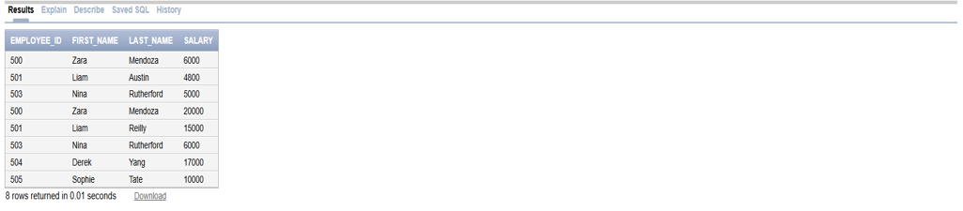

1.b. Select * from employees where manager_id = 100;

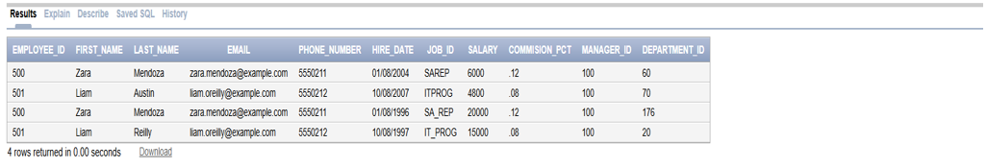

1.c. Select First_name, last_name from employees where salary >=100;

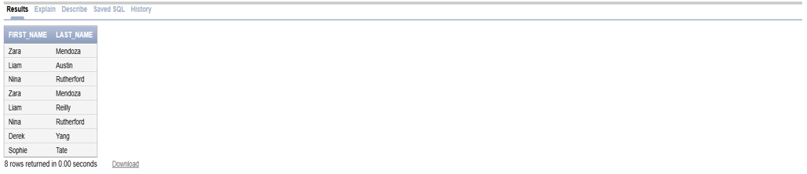

1.d. Select * from employees where last_name = ‘Austin’;

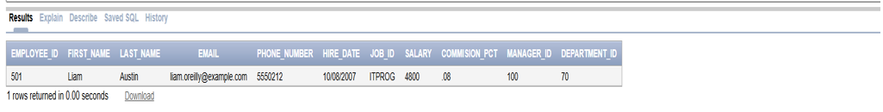

1.e. Select first_name, last_name, from employees where department_id = 60 or department_id = 10 or department_id = 80;

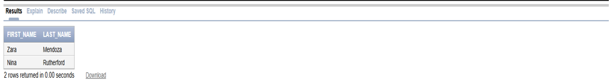

1.f. Select distinct manager_id from employees;

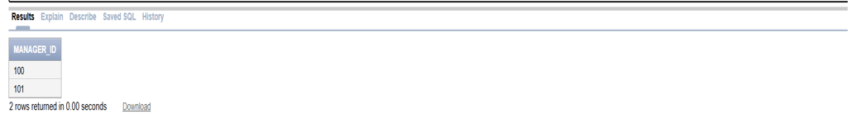

2.a. BEGIN

INSERT INTO emps (EMPNO, EMPNAME, JOB, BASIC, DA, HRA, PF, GROSSPAY, NETPAY)

VALUES(1, 'John Smith', 'Manager', 20000, NULL, NULL, 2000, 22000, 20000);

INSERT INTO emps (EMPNO, EMPNAME, JOB, BASIC, DA, HRA, PF, GROSSPAY, NETPAY)

VALUES(2, 'Jane Doe', 'Engineer', 18000, NULL, NULL, 1800, 19800, 18000);

INSERT INTO emps (EMPNO, EMPNAME, JOB, BASIC, DA, HRA, PF, GROSSPAY, NETPAY)

VALUES(3, 'Bob Johnson', 'Salesman', 25000, NULL, NULL, 2500, 27500, 25000);

INSERT INTO emps (EMPNO, EMPNAME, JOB, BASIC, DA, HRA, PF, GROSSPAY, NETPAY)

VALUES(4, 'Alice Brown', 'Accountant', 22000, NULL, NULL, 2200, 24200, 22000);

INSERT INTO emps (EMPNO, EMPNAME, JOB, BASIC, DA, HRA, PF, GROSSPAY, NETPAY)

VALUES(5, 'Mike Davis', 'Consultant', 30000, NULL, NULL, 3000, 33000, 30000);

END;  
  
Output: 5 row(s) inserted

2.b. Select empname,job,basic from emps where basic in (select min(basic) from emps group by job);

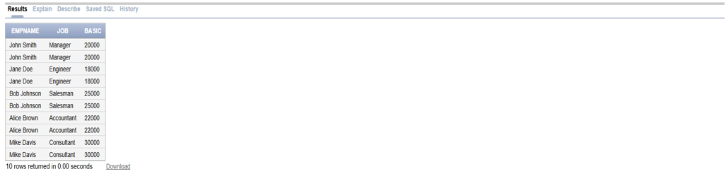

2.c. select empno, empname,netpay,from emps where netpay>10000;

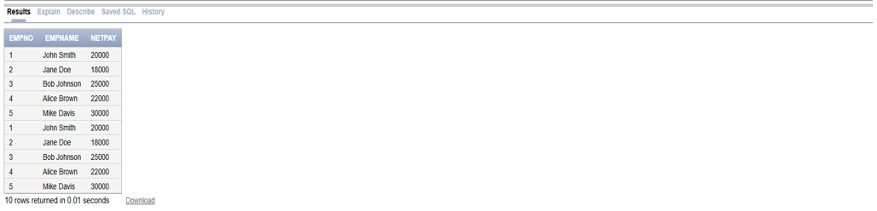

3.

a.Create table departmentid (deptid number(6), deptname varchar2(20), managerid number(6), locationid number(4));

Create table jobgrade(deptid varchar2(2), deptname number, managerid number);

Create table location(location number(4), staddr varchar2 (40), postalcode varchar(12), city varchar2(30), state_province varchar(25), countryid char(2));

b. create table emp1(id number(7), lastname varchar2(25), firstname varchar2(25), deptid number (7));

c. alter table emp1 modify(lastname varchar(50));

d. create table emp2(employeeid number(7), firstname varchar2(25), lastname varchar2(25), salary number (8,2), deptid number(7));

e. drop table emp1;

f. rename emp2 top emp;

g. comment on table dept1 is ‘this contains data about the employees2’;

h. alter table emp drop column firstname;